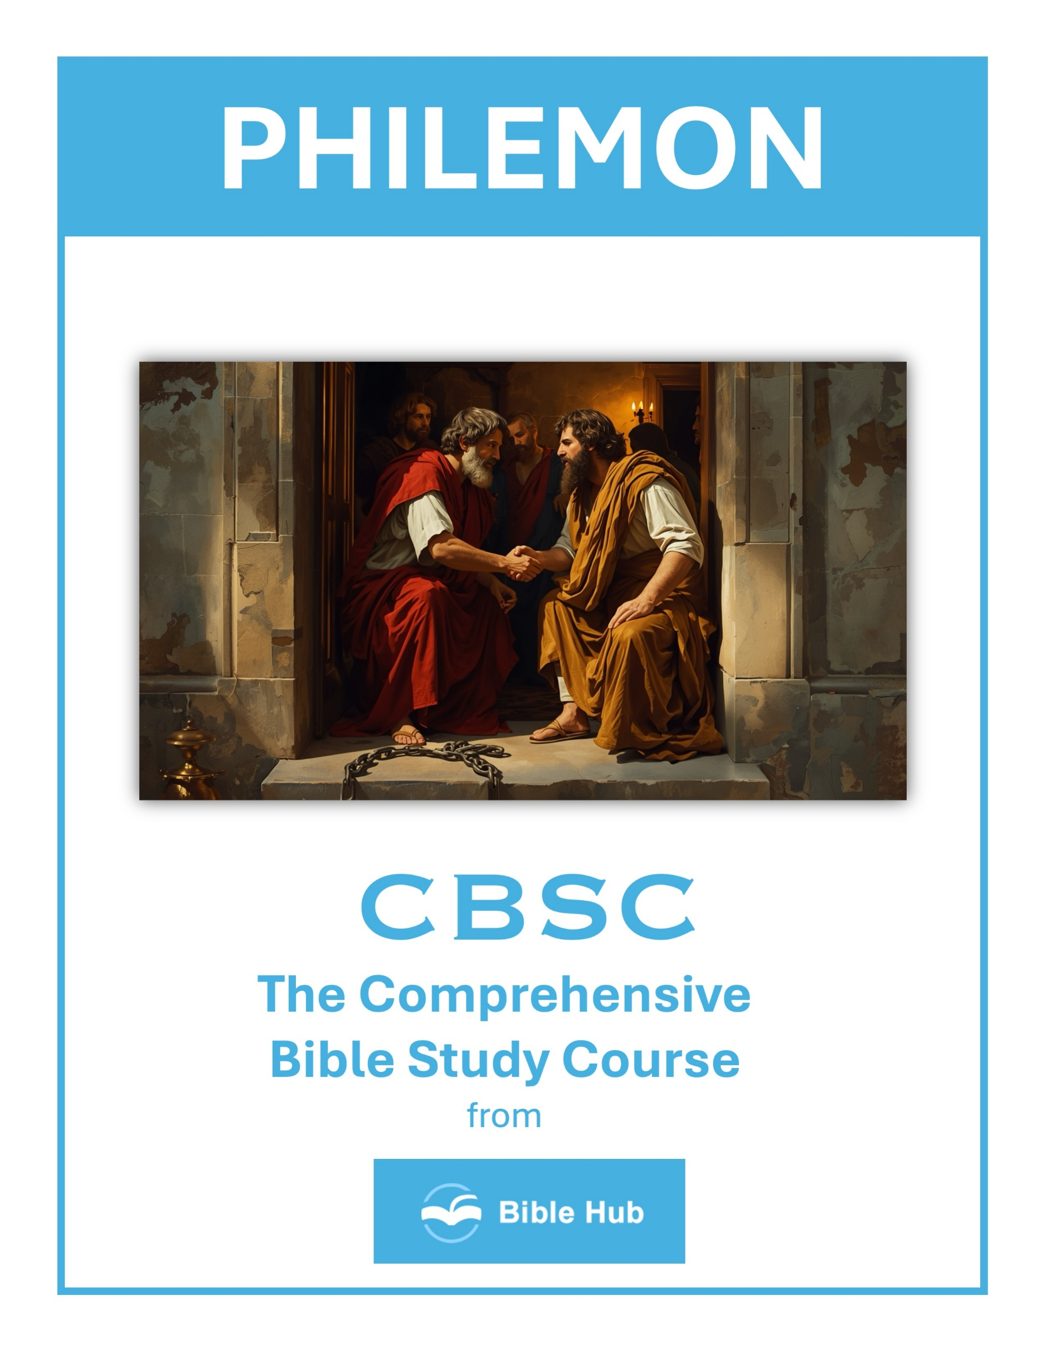

Philemon 1 Teaching Points and Bible Study Questions
The Power of Love and Forgiveness
In Philemon 1:9, Paul appeals to Philemon "on the basis of love." This highlights the transformative power of love and forgiveness in our relationships. When we choose to forgive, we reflect the love of Christ, who forgave us first. Let love be the driving force in your interactions, and watch how it changes hearts and lives.
1. How can you apply love and forgiveness in a conflict with a friend or family member today?
2. Why do you think forgiveness is essential for healing and restoring relationships in your life?
3. What can you do to demonstrate love and forgiveness in challenging situations at work or school?
The Importance of Intercession
Paul's letter is a beautiful example of intercession. He stands in the gap for Onesimus, advocating on his behalf. As believers, we are called to intercede for others, lifting them up in prayer and support. Remember, "The prayer of a righteous man has great power to prevail" (James 5:16).
1. How can you practice intercession in your daily life to support others in their struggles?
2. Why do you think intercession is crucial in building and maintaining strong community relationships?
3. What can you learn from Paul's intercession for Onesimus that applies to your own relationships?

The Value of Every Individual
Paul refers to Onesimus as "my very heart" (Philemon 1:12). This shows that every person has intrinsic value and worth. In a world that often overlooks the individual, remember that each person is precious in God's sight, created in His image.
1. How can you demonstrate the value of every individual in your daily interactions and relationships?
2. Why do you think recognizing each person's worth is essential in building a supportive community?
3. What can you do to ensure everyone feels valued and respected in your workplace or social circle?
The Role of Reconciliation
Reconciliation is a central theme in Philemon. Paul encourages Philemon to welcome Onesimus "no longer as a slave, but better than a slave, as a dear brother" (Philemon 1:16). This teaches us the importance of mending broken relationships and seeking unity in Christ.
1. How can you apply the principles of reconciliation in your personal relationships today?
2. Why do you think reconciliation is essential for community harmony and personal growth?
3. What steps can you take to facilitate reconciliation in a conflict you are currently facing?

The Impact of a Good Reputation
Paul begins his letter by commending Philemon for his love and faith, which have "refreshed the hearts of the saints" (Philemon 1:7). A good reputation built on faith and love can open doors for ministry and influence. Strive to live in a way that honors God and inspires others.
1. How can maintaining a good reputation influence your relationships within your community and church?
2. Why do you think Paul emphasizes Philemon's reputation in his appeal for Onesimus?
3. What can you do daily to build and maintain a positive reputation among peers and family?
The Joy of Partnership in the Gospel
Paul speaks of Philemon as a "partner" in the faith (Philemon 1:17). This partnership is a reminder that we are not alone in our Christian walk. We are part of a larger community, working together to spread the Gospel and support one another in love.
1. How can you actively contribute to the joy of partnership in your faith community today?
2. Why do you think mutual support is essential for effective gospel partnership?
3. What practical steps can you take to strengthen your partnership in spreading the gospel?

The Call to Do What is Right
Paul expresses confidence that Philemon will do "even more than I ask" (Philemon 1:21). This encourages us to go above and beyond in doing what is right, not out of obligation, but out of a sincere desire to honor God and serve others.
1. How can you apply Paul's appeal to Philemon in your own relationships today?
2. Why do you think doing what is right can sometimes be challenging in personal conflicts?
3. What steps can you take to ensure your actions align with your values and beliefs?
The Influence of a Godly Example
Paul's life and actions serve as a powerful example to Philemon and to us. By living out our faith authentically, we can inspire others to follow Christ. As Paul writes in 1 Corinthians 11:1, "Imitate me, as I imitate Christ."
1. How can you apply Paul's example of encouragement in your relationships today?
2. Why do you think a godly example is powerful in transforming others' lives?
3. What can you do to be a godly influence in your community this week?

The Significance of Spiritual Growth
Paul's letter to Philemon is not just about Onesimus's return but also about spiritual growth and maturity. As we grow in our faith, we become more effective in our witness and more aligned with God's purposes.
1. How can Philemon's example inspire you to foster spiritual growth in your community today?
2. Why do you think spiritual growth is essential for resolving conflicts, as seen in Philemon's story?
3. What practical steps can you take to encourage spiritual growth in your personal relationships?
The Assurance of God's Sovereignty
Finally, the story of Philemon reminds us of God's sovereignty. What seemed like a chance encounter between Paul and Onesimus was part of God's divine plan. Trust that God is at work in your life, orchestrating events for His glory and your good.
These lessons from Philemon encourage us to live out our faith with love, integrity, and a heart for reconciliation, reflecting the character of Christ in all we do.
1. How can recognizing God's sovereignty in Philemon 1 influence your response to challenging relationships today?
2. Why do you think acknowledging God's control can change your perspective on forgiveness and reconciliation?
3. What practical steps can you take to trust God's sovereignty in uncertain situations, as seen in Philemon 1?

